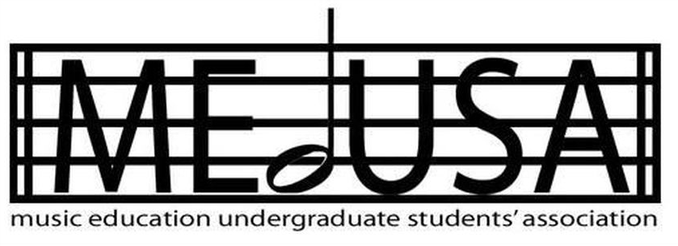
Music Education Undergraduate Students’ Association
Executive Meeting
Montreal, QC

Meeting Minutes

Members Present:

Regrets:

- Call to Order at: motioned by , seconded by

- Welcome & Announcements:

- Approval of Previous Minutes: Motioned by , seconded by

- Action Items from Previous Meetings:
  - President:
    - Make doodle poll for exec availabilities
  - First Year Rep:
    - RVC Lounge
  - ALL:
    - Reach out to EDUS counterpart

- President Report:
  - ISA Meeting
  - Hot Beverage Sale
    - Sign up for a tabling shift by Wednesday
    - Kettle?
    - Update on frosh mugs?
    - Facebook event
  - Check-ins
    - Benelux outing
    - Holiday event → alcohol order (Lisa), room
    - Lab band → advertise, Trois Brasseurs event
    - EdUS counterparts
    - Council sweaters
- Communication
  - Facebook group → please contribute
  - MEdUSA email and job postings

- VP Finance Report:
  - Budget:
    - Budget numbers for this term have been determined to be $2302 this semester, which calculates EdUS's allocation as 80% of last year's fall allocation as a precaution.
    - Approximately $450 of this has been used so far, but I am still entering in the last of the transaction numbers for this term.
  - Workshop fee:
    - raising the workshop guest fee from $125 to $150. Last year I initiated the vote which raised to $125 from $100. Consider the preparation, the parking they need to find, the materials they use, and the knowledge they bring with them. Vote?
  - Apparel:
    - I will be asking everybody to pay $5 as a formality. Vote?

- VP Academic Report:
  - Music for People
    - Scholarship process - let’s discuss
    - Publicity - Facebook event for scholarship application, poster, description, etc.
  - EdUS
    - Thank you Ben for attending the meeting last week!
    - EdUS Counterparts - David, Alice, Beatrice please reach out
    - Holding a GA sometime in January about student-teacher strike

- VP Professional Development Report:
  - 1st workshop (winter semester)
    - Choral Conducting workshop
    - our ideas
  - 2nd workshop (winter semester)
    - Truth and Reconciliation Commission (TRC)
    - In collaboration with Prof. Jim Howden, an indigenous student from McGill, maybe an Elder or someone from an indigenous community near Mtl.
    - Workshop not specifically for music education
    - "Bigger" event so maybe book a room like C-201?
    - What are your thoughts on this subject? Are you interested
- VP Social Report:
  - Post Lab Band social:
    - Thursday November 28th 9:30PM
    - 3 Brasseurs McGill 732 Ste-Catherine W
    - Everyone welcome, first drink on MEdUSA for music ed people
  - Benelux Outing Recap:

- VP Communications Report:
  - Hot Beverage Sale:
    - Cups
  - IG proposals
  - Council swag orders
    - waiting on Neil
  - MUSA/MEdUSA co-formal event

- First Year Representative/Bachelor of Education Representative Report:
  - MUSA Bar Availabilities
    - MEdUSA’s availabilities:
  - Keys:
    - Senior council members contacting former council members they know to see if they’ve returned keys

- Next meeting date on:
  - 2020!!! AHHHHH TBD

- Adjournment at: Motioned by , seconded by

Further Outstanding Action Items:

